 | 26.14.8 Editors - Properties Editor - Object Data Properties Tab - Grease Pencil Object
Table of content
Detailed table of content 2
Layers panel 5
Layer list 5
Add New Layer 6
Add New Layer Group 6
Remove Layer Group 6
Add Extra menu 7
Reorder Layer 8
Isolate Layers 9
Isolate layers 9
Autolock Inactive layers 9
Ignore Material Locking 9
Blend Mode 9
Opacity 9
Use Scene Lighting 9
Layers panel - Masks subpanel 9
List view 9
Add 10
Subtract 10
Move Up / Down 10
Layers panel - Transform subpanel 10
Layers panel - Adjustment subpanel 10
Tint Color 10
Stroke Thickness 10
Layers panel - Relations subpanel 10
Parent 11
Type 11
Bone 11
Pass Index 11
View Layer 11
Layers panel - Display subpanel 11
Custom Channel Color 11
Show Only On Keyframed 11
Onion Skinning Panel 12
Mode 12
Opacity 12
Filter By Type 12
Keyframes Before/After 12
Custom Colors 12
Display 13
Settings Panel 13
Stroke depth order 13
Attributes panel 13
Add Attribute + 13
Remove Attribute - 13
Attribute Specials menu 13
Vertex groups panel 14
Active Vertex Group list 14
Add + 15
Remove - 15
Vertex Group Specials menu 15
Move Vertex Group Up 17
Move Vertex Group Down 17
Assign 17
Remove 17
Select 17
Deselect 17
Weight 17
Custom Properties Panel 17
Add 17
Edit 17
Remove 17

Detailed table of content
Detailed table of content
Detailed table of content 2
Layers panel 6
Layer list 6
Layer name 6
Grease pencil layers right click menu 6
Edit Source 6
Reset Panel Zoom 6
Delete Group 6
Ungroup 6
Merge Group 7
Colors 7
Mask Layer 7
Onion Skinning 7
Viewport/Render Visibility 7
Lock 7
Search Field 7
Add New Layer 7
Add New Layer Group 7
Remove Layer Group 7
Add Extra menu 8
Add Group 8
Delete Group 8
Ungroup 8
Merge Group 8
Move To Top 8
Move To Bottom 8
Duplicate Layer 8
Duplicate Empty Keyframes 9
Show All 9
Hide Others 9
Lock All 9
Unlock All 9
Merge Down 9
Merge All 9
Mask with Layer Above 9
Mask with Layer Below 9
Copy Layer to Selected 9
Copy all Layers to Selected 9
Reorder Layer 9
Isolate Layers 10
Isolate layers 10
Autolock Inactive layers 10
Ignore Material Locking 10
Blend Mode 10
Opacity 10
Use Scene Lighting 10
Layers panel - Masks subpanel 10
List view 10
Name of the grease pencil layer 10
Invert 10
Hide 10
Search Field 11
Add 11
Subtract 11
Move Up / Down 11
Layers panel - Transform subpanel 11
Layers panel - Adjustment subpanel 11
Tint Color 11
Factor 11
Stroke Thickness 11
Layers panel - Relations subpanel 11
Parent 12
Type 12
Bone 12
Pass Index 12
View Layer 12
Use Masks in Render 12
Layers panel - Display subpanel 12
Custom Channel Color 12
Show Only On Keyframed 12
Onion Skinning Panel 13
Mode 13
Frames 13
Keyframes 13
Selected 13
Opacity 13
Filter By Type 13
Keyframes Before/After 13
Custom Colors 13
Display 14
Fade 14
Show Start Frame 14
Settings Panel 14
Stroke depth order 14
2D Layers 14
3D Location 14
Attributes panel 14
Add Attribute + 14
Remove Attribute - 14
Attribute Specials menu 15
Convert Attrribute 15
Name 15
Domain 15
Data Type 15
Vertex groups panel 15
Active Vertex Group list 15
Group name 16
Lock 16
Drag Handler 16
Search Field 16
Invert 16
Sort by Name 16
Add + 16
Remove - 16
Vertex Group Specials menu 16
Sort by Name 16
Sort by Bone Hierarchy 16
Copy Vertex Group 16
Copy Vertex Groups to Linked 17
Copy Vertex Group to Selected 17
Mirror Vertex Group 17
Mirror Vertex Group (Topology) 17
Remove from All Groups 17
Clear Active Group 17
Delete All Unlocked Groups 17
Delete All Groups 17
Lock All 17
Unlock All 17
Lock Invert All 17
Move Vertex Group Up 18
Move Vertex Group Down 18
Assign 18
Remove 18
Select 18
Deselect 18
Weight 18
Custom Properties Panel 18
Add 18
Edit 18
Remove 18

Layers panel

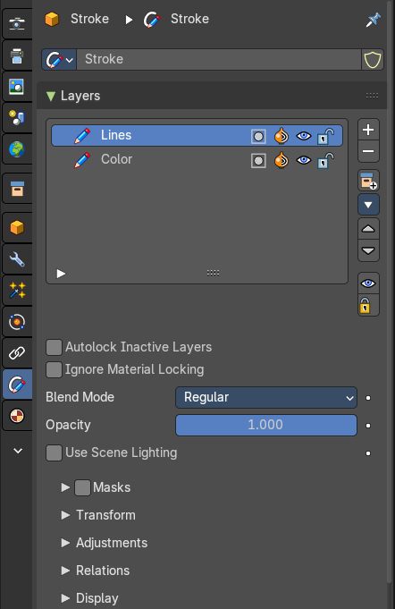
Grease Pencil objects each have a list of 2D layers for grouping and arranging strokes in a List view. Any stroke can only belong to a single 2D layer. There is always only one active layer in the list (the selected one). When you draw, the new strokes are added to the active layer. By default the view order of the layers in the viewport is top to bottom.
Every layer correspond to a channel in the Dope Sheet editor (in Grease Pencil mode). Layers can also be used together with Modifiers to only affects part of your drawing.

Layer list

Layer name
The name of the layer.

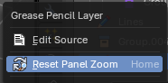
Grease pencil layers right click menu
A right click at a group in the list reveals a menu with further options.
When you click at a group layer, then you will reveal further options.

Edit Source
Allows you to edit the source code.

Reset Panel Zoom
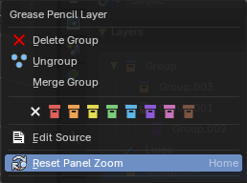
Resets the zoom of the panel to the default value. Note that this entry is dysfunctional. You cannot zoom the panel.

Delete Group
Deletes the selected group. It does not keep the children, and deletes the whole hierarchy.

Ungroup
Ungroups the selected group.

Merge Group
Combine the layers in this group into a single layer.

Colors
Allows you to color your layer groups in the list. It does not show

Mask Layer
Toggle the Masks visibility in the layer.

Onion Skinning
Toggle the use the layer for Onion Skinning.

Viewport/Render Visibility
Toggle layer visibility in the viewport and in render.

Lock
Toggle layer from being editable.

Search Field
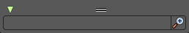
You can expand a search field at the bottom of the list. Type in your term and hit enter to filter for your term.

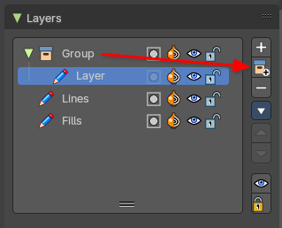
Add New Layer
Adds a new layer.

Add New Layer Group
Adds a group. You can then drag n drop layers into it.

Remove Layer Group
Deletes the selected group. But keeps the children, and the hierarchy.

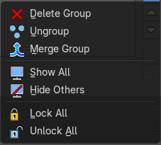
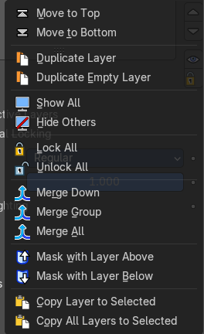
Add Extra menu
Extra operators per layer or layer group.

Add Group
Adds a group. You can then drag n drop layers into it. The group will be added as a child when you have a group selected.

Delete Group
Deletes the selected group.
Note: Only shows on Layer Groups

Ungroup
Ungroups the selected group.
Note: Only shows on Layer Groups

Merge Group
Merges any children groups with parent group. If there are no children groups, it will merge no layer groups.
Note: Only shows on Layer Groups

Move To Top
Moves the active selected grease pencil layer to top

Move To Bottom
Moves the active selected grease pencil layer to bottom

Duplicate Layer
Makes an exact copy of the selected layer appending a number to differentiate its name. This method does not duplicate empty keyframes.

Duplicate Empty Keyframes
Makes an exact copy of the selected layer appending a number to differentiate its name. This method does duplicate empty keyframes.

Show All
Turns on the visibility of every layer in the list.

Hide Others
Turns off the visibility of every layer in the list except the active one.

Lock All
Locks edition of all the layers in the list

Unlock All
Unlocks edition of all the layers in the list.

Merge Down
Merge the selected layer with the layer below. The new layer keeps the name of the lower layer.

Merge All
Merge the selected layer with all layers. The new layer keeps the name of the active layer.

Mask with Layer Above
Mask the active layer with the layer above.

Mask with Layer Below
Mask the active layer with the layer below

Copy Layer to Selected
Appends the active layer to the selected object.

Copy all Layers to Selected
Appends all layers to the selected object.

Reorder Layer
Move the selected layer up or down in the list.

Isolate Layers
Locks and hides all not active layers.

Isolate layers
Locks all not active layers.

Autolock Inactive layers
Automatically lock all layers except the active one to avoid accidental changes

Ignore Material Locking
Allow editing strokes even if they use locked materials.

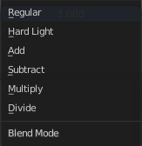
Blend Mode
The layer blending operation to perform. See Color Blend Modes.

Opacity
Used to set the opacity of the layer.

Use Scene Lighting
When enabled, the layer is affected by lights.

Layers panel - Masks subpanel

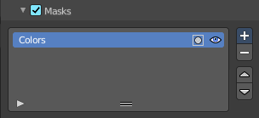
Use another grease pencil layer as a mask.

List view

Name of the grease pencil layer
The name of the layer.

Invert
Invert the mask.

Hide
Set mask layer visible or invisible.

Search Field
You can expand a search field at the bottom of the list. Type in your term and hit enter to filter for your term.

Add
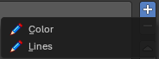
Add a grease pencil layer as a mask layer. The layer must already exist.

Subtract
Remove the grease pencil layer from the list.

Move Up / Down
Move the selected grease pencil mask one up or one down.

Layers panel - Transform subpanel

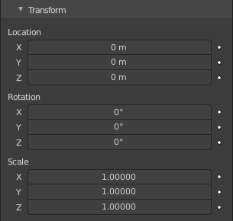
Allows to transform the current grease pencil layer in the 3d view.

Layers panel - Adjustment subpanel
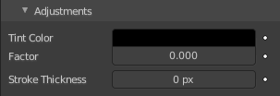

Tint Color
Color that tint any material colors used in the layer.

Factor
The Factor controls the amount of tint color to apply.

Stroke Thickness
Thickness value that override the strokes thickness in the layer.

Layers panel - Relations subpanel

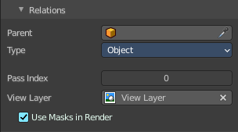
Select a Parent object and Type to manipulate the layer. The layer will inherit the transformations of the parent.
This can be used for rigging for cut-out animation.

Parent
The Parent object.

Type
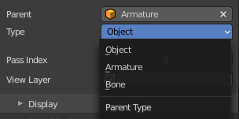
What type of object. When the parent is an armature, then you can choose between object, armature or bone.

Bone
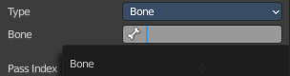
When the type is a bone, then choose which bone of the armature.

Pass Index
The layer index number. It can be used with some modifiers to restrict changes to only certain areas.

View Layer
Defines the View Layer to use for the Grease Pencil layer. If empty, the layer will be included in all View Layers. This is useful to separate drawings parts for compositing.

Use Masks in Render
Include the mask layer when you render the view layer. You need to have a view layer selected to reveal this option.

Layers panel - Display subpanel

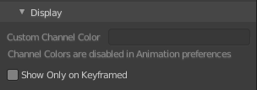
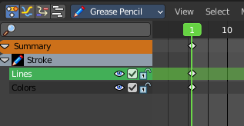
Custom Channel Color
Sets the color to use in the channel region of the Dope Sheet.


Show Only On Keyframed
The layer is just visible in the viewport if it has a keyframe in the actual frame.

Onion Skinning Panel
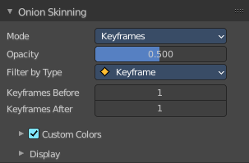
Onion Skinning show ghosts of the keyframes before and after the current frame. This allows animators to judge and pose in between two frames.

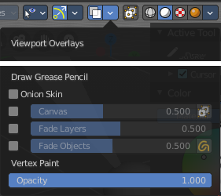

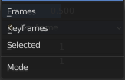
Mode

Frames
Shows Frames in the range determined by the Before/After settings.

Keyframes
Shows Keyframes in the range determined by the Before/After settings.

Selected
Shows only on the manually selected keyframes in the Dope Sheet.

Opacity
Control the opacity of the ghost frames.

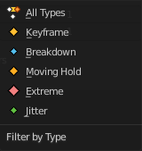
Filter By Type
Filters what type of frames to show in the Onion Skinning range.

Keyframes Before/After
Sets how many frames or keyframes, depending on the Mode, to show before and after the current frame.

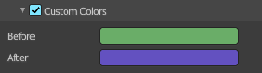
Custom Colors
Before/After
Custom color of the ghost frames before and after the current frame.

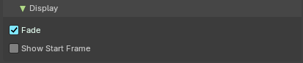
Display

Fade
Opacity of the ghosts frames decrease the further away from the current frame.

Show Start Frame
Display onion keyframes on looping animations.

Settings Panel

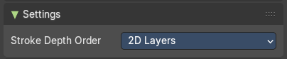

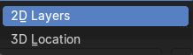
Stroke depth order

2D Layers
Display strokes by using the Grease Pencil layer order and stroke order to define depth.

3D Location
Display strokes by using the real 3D position in 3D space.

Attributes panel
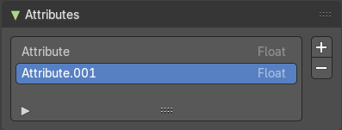
A list of the attributes at this object. Attributes can be used to identify an object in the shader editor or the geometry nodes editor

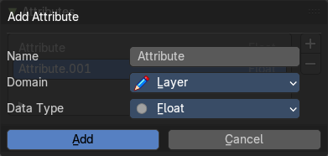
Add Attribute +
A List of the attributes for this mesh.

Remove Attribute -
Delete the selected attribute.

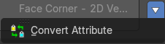
Attribute Specials menu

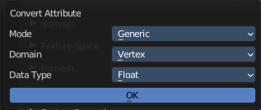
Convert Attrribute
Change how the selected attribute is stored.
This operator opens a popup menu where you can change the settings of the attribute.

Name
The name of the attribute.


Domain
Type of element that the attribute is stored on. In this case the grease pencil layer.

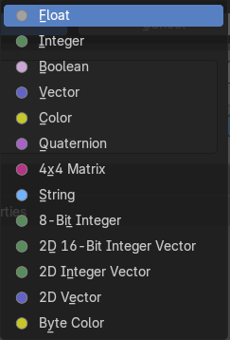
Data Type
Just Generic. What data type to use for the attribute calculation.

Vertex groups panel

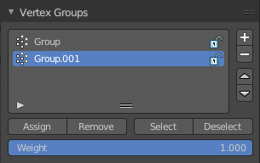
A Vertex group is a group of vertices, a selection of the mesh. It is for example used to weight a specific mesh part to a bone. Or to control the growth of hair particles.
This panel allows you to manage and edit vertex groups. Weight painting creates vertex groups automatically.
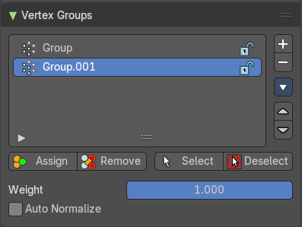
In Edit mode this panel shows the inactive controls active.
Vertex groups exists for mesh and lattice objects.

Active Vertex Group list
A List of the vertex groups for this mesh.

Group name
The name of the group. It can be renamed by double clicking at it.

Lock
The lock icon at the end of a group name locks the group from being editable.

Drag Handler
The two vertical lines at the end is a handler with which you can expand the list.

Search Field

You can expand a search field at the bottom of the list. Type in your term and hit enter to filter for your term.

Invert
Exclude the search term instead of searching for it.

Sort by Name
Sort the List by name.

Add +
Create an empty vertex group.

Remove -
Deletes the active vertex group.

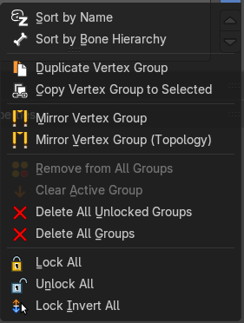
Vertex Group Specials menu

Sort by Name
Sorts the vertex groups alphabetically by name.

Sort by Bone Hierarchy
Sorts the vertex groups by the hierarchy of the assigned bones.

Copy Vertex Group
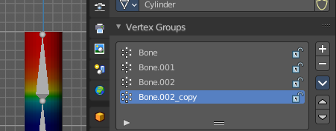
Add a copy of the active vertex group as a new group. The new group will be named like the original group with “_copy” appended at the end of its name. And it will contain associations to exactly the same vertices with the exact same weights as in the source vertex group.

Copy Vertex Groups to Linked
Copy vertex groups of this mesh to all linked objects which use the same mesh data (all users of the data).

Copy Vertex Group to Selected
Copy all vertex groups to other selected objects provided they have matching indices (typically this is true for copies of the mesh which are only deformed and not otherwise edited).

Mirror Vertex Group
Mirrors weights and/or flips group names from one side of a symmetrical mesh to the other.
Only mirroring along local X axis is supported. Vertices that have no corresponding vertex on the other side will not be affected. Note, the weights are not transferred to the corresponding opposite bone weight group.

Mirror Vertex Group (Topology)
Performs the Mirror Vertex Group with the Topology Mirror option enabled.

Remove from All Groups
Unassigns the selected vertices from all groups. Even locked.

Clear Active Group
Remove all assigned vertices from the active group. The group is made empty. Note that the vertices may still be assigned to other vertex groups of the object. This feature does not affect locked groups.

Delete All Unlocked Groups
Remove all vertex groups from the object that are not locked.

Delete All Groups
Remove all vertex groups from the object.

Lock All
Lock all groups.

Unlock All
Unlock all groups.

Lock Invert All
Invert group locks.

Move Vertex Group Up
Moves the selected vertex group up in the list.

Move Vertex Group Down
Moves the selected vertex group down in the list.

Assign
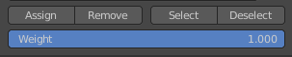
Assign the selected vertices to the active vertex group.

Remove
Remove the selected vertices from the active group.

Select
Select all vertices in the group.

Deselect
Deselect all vertices in the group.

Weight
The weight value that gets assigned to the selected vertices.

Custom Properties Panel


Here you can define custom properties that can be used for scripting.

Here you might also find custom properties from addons or scripts.

Add
Adds a new property.


Edit
Opens a panel where you can adjust the settings for the custom property.

Remove
Removes the property.

